Project Design Phase
Solution Architecture
Date | 18 February 2025
Team ID | LTVIP2026TMIDS89357
Project Name | explore with ai: custom itineraries for your next journey
Maximum Marks | 4 Marks

Solution Architecture:
Solution architecture for Explore with AI: Custom Travel Itineraries is a structured process that connects traveller needs with intelligent technology services. It ensures that personalized travel plans are generated efficiently, securely, and delivered through seamless conversational experiences.
Its goals are to:
● Identify the most effective AI and cloud technologies to solve traveller planning challenges, such as generating personalized itineraries based on preferences, budget, and duration.
● Describe the overall structure and behaviour of the system, including how user requests flow through conversational interfaces, AI services, backend logic, and storage systems, so stakeholders clearly understand how the solution operates.
● Define key features, development stages, and system requirements, such as voice interaction, itinerary generation, data storage, notification delivery, and integration with cloud services.
● Provide clear technical specifications and architectural guidelines that ensure the solution is designed, implemented, managed, and delivered reliably using scalable cloud components like conversational AI, serverless compute, and secure data storage.

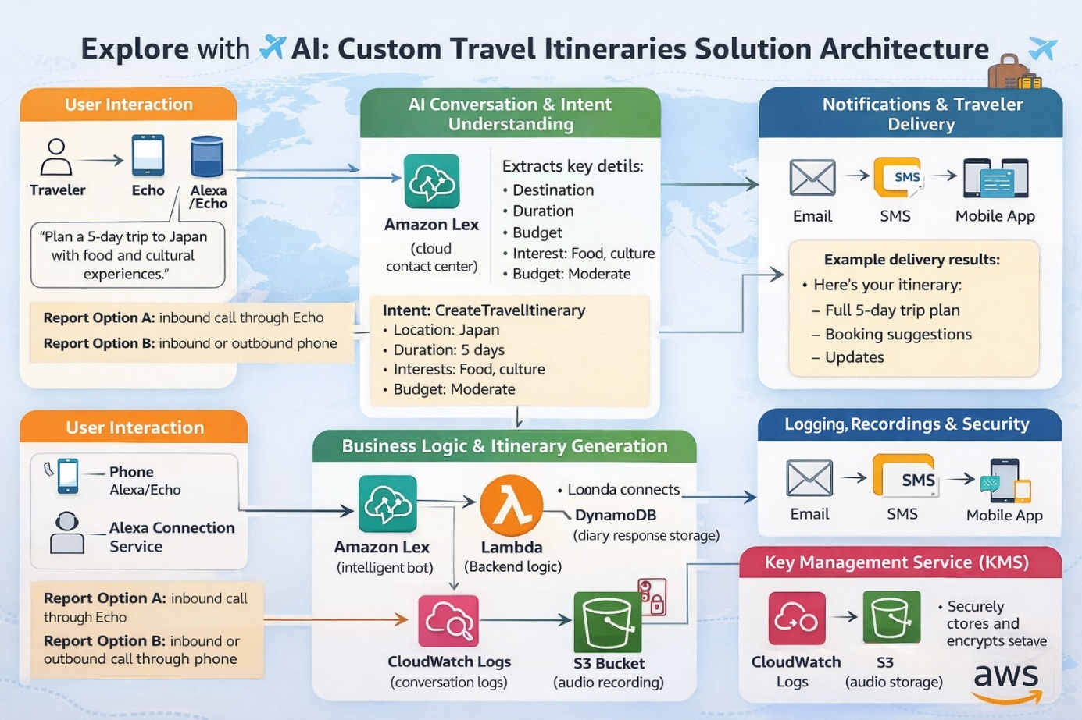
Figure 1: Architecture and data flow of the voice patient diary sample application

